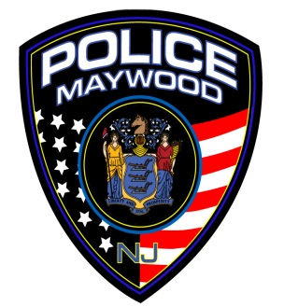  **Maywood Police Department**

15 Park Avenue

Maywood New Jersey 07607-2015

(201) 845-8800

Fax (201) 845-0304

**INSTRUCTIONS FOR ALL CONCEALED CARRY PERMIT APPLICANTS**

**(Effective September 19, 2023)**

The Maywood Police Department is connected to the State of New Jersey Concealed Carry Permit Portal. Paper applications are no longer being accepted. DO NOT START THE APPLICATION UNTIL YOU HAVE OBTAINED ALL OF THE REQUIRED INFORMATION AND DOCUMENTS. To submit a concealed carry permit application to MPD:

* Prior to starting this process, you will need to have completed the required NJ course of fire with a firearm owned by you. The qualified firearms instructor will provide you with a completed NJ Training Record form. After you have this documentation, proceed with the below process.
* Visit [www.njportal.com/NJSP/ConcealedCarry](http://www.njportal.com/NJSP/ConcealedCarry)
* Click “**Start Initial Application”**
* Enter **NJ0023400** as ORI Number. This number is for the Borough of Maywood residents only. If you reside outside of the Borough of Maywood, contact the law enforcement agency responsible for your town to find out the correct ORI Number.
* Answer the requisite questions and then upload a photograph consistent with the instructions set forth on the application portal. Additionally note, the photograph should be from the shoulders and up. Press continue and proceed with the remainder of the application.
* When completing the application, you will need the names, addresses and email addresses of four **(4)** non-family references. Please inform your references they will be e-mailed reference questions, which they should respond to promptly in order to avoid delaying the application.
* You will need a credit card to pay the required state background check fees at this time.
* You will then need to respond to the Maywood Police Department in person with a print out of your application confirmation page, and required statutory permit fees of $150. This must be exact cash, or a check/money order payable to the “Borough of Maywood” in the amount of $150. The desk officer will collect your payment, issue you a receipt, and forward it to the Firearms Unit.
* Applications will not be approved until payment is made. Failure to submit payment may delay the processing of your application, or its eventual withdrawal.
* Once processing of your application is complete, your carry permit will be sent to your e-mail electronically by the State of NJ Portal. There will be no documents to pick up from the police department. You will be required to print it out, and comply with all of the requirements set forth in NJSA 2C:58-4 et seq.

This process is applicant driven. Please ensure that you have provided the best contact number and e-mail address for yourself. It is your responsibility to ensure all information is thorough, accurate, and complete. Failure to do so can result in a delay, denial, or withdrawal of the application, along with having to pay application fees again (these are non-refundable). If you made a mistake in the application process, contact us BEFORE submitting a new application. **Please also regularly check your e-mail (including SPAM folders) for any communications from the Firearms Unit.**

If you have any questions, please contact the Maywood PD Firearms Unit at 201-845-8800 or via e-mail spatton@maywoodpd.org